**Aim:** To design a Maintaining Social Distancing circuit using a few electrical components like Ultrasonic Distance Sensor using TinkerCad and interface it with Arduino.

**Ultrasonic Distance Sensor –** An ultrasonic sensor is an electronic device that measures the distance of a target object by emitting ultrasonic sound waves, and converts the reflected sound into an electrical signal. Ultrasonic waves travel faster than the speed of audible sound (i.e. the sound that humans can hear). Ultrasonic sensors have two main components: the transmitter (which emits the sound using piezoelectric crystals) and the receiver (which encounters the sound after it has travelled to and from the target).

**Piezo Buzzer –**A "piezo buzzer" is basically a tiny speaker that we can connect directly to an Arduino. "Piezoelectricity" is an effect where certain crystals will change shape when we apply electricity to them. By applying an electric signal at the right frequency which will be done as per the conversion of the gas sensor, the crystal can make sound.

These two devices will act as the backbone of the project that will be accompanied by wires and resistors from the Arduino.

# Objectives:

1. To learn Arduino UNO basics.
2. To Learn about Piezo buzzer basics.
3. To Learn about Ultrasonic Distance Sensor

# Theory:

**Arduino Uno R3:**

Arduino Uno R3 is one kind of ATmega328P based microcontroller board. It includes the whole thing required to hold up the microcontroller; just attach it to a PC with the help of a USB cable, and give the supply using AC-DC adapter or a battery to get started. The term Uno means “one” in the language of “Italian” and was selected for marking the release of Arduino’s IDE 1.0 software. The R3 Arduino Uno is the 3rd as well as most recent modification of the Arduino Uno. Arduino board and IDE software are the reference versions of Arduino and currently progressed to new releases. The Uno-board is the primary in a sequence of USB- Arduino boards, & the reference model designed for the Arduino platform.

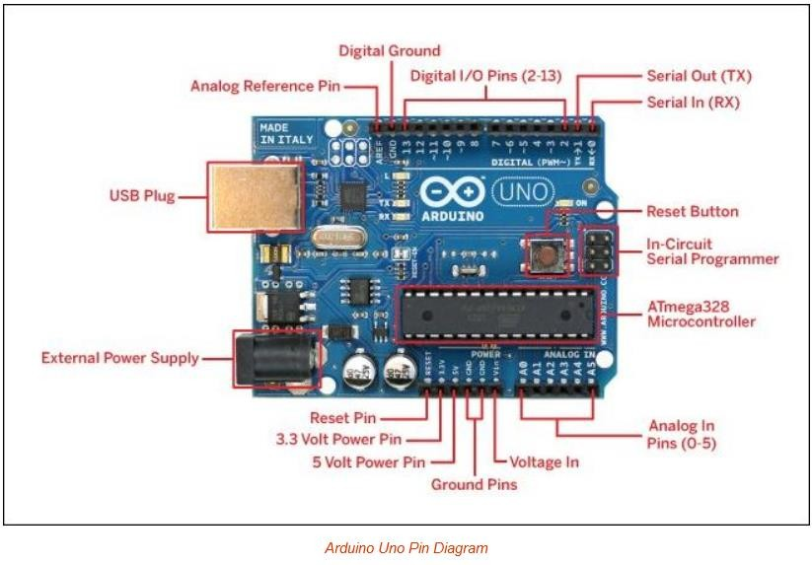

# Ultrasonic Distance Sensor:

An ultrasonic sensor is an electronic device that measures the distance of a target object by emitting ultrasonic sound waves, and converts the reflected sound into an electrical signal. Ultrasonic waves travel faster than the speed of audible sound (i.e. the sound that humans can hear). Ultrasonic sensors have two main components: the transmitter (which emits the sound using piezoelectric crystals) and the receiver (which encounters the sound after it has travelled to and from the target).

In order to calculate the distance between the sensor and the object, the sensor measures the time it takes between the emission of the sound by the transmitter to its contact with the receiver.

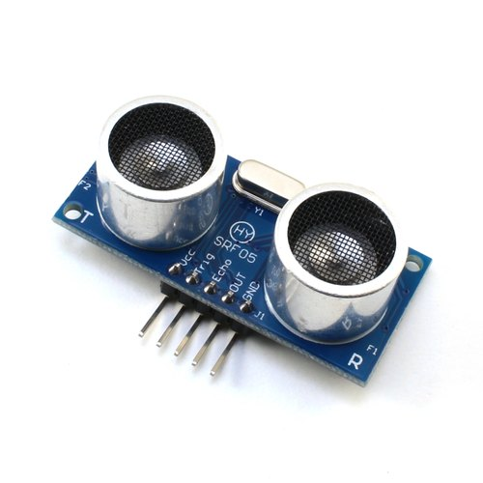

# Piezo Buzzer :

Piezo buzzers are simple devices that can generate basic beeps and tones. They work by using a piezo crystal, a special material that changes shape when voltage is applied to it. If the crystal pushes against a diaphragm, like a tiny speaker cone, it can generate a pressure wave which the human ear picks up as sound. Simple change the frequency of the voltage sent to the piezo and it will start generating sounds by changing shape very quickly!

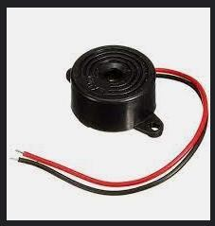

# Resistor:

A resistor is an electrical component that limits or regulates the flow of electrical current in an electronic circuit. Resistors can also be used to provide a specific voltage for an active device such as a transistor.

All other factors being equal, in a direct-current (DC) circuit, the current through a resistor is inversely proportional to its resistance, and directly proportional to the voltage across it. This is the well-known Ohm's Law. In alternating-current (AC) circuits, this rule also applies as long as the resistor does not contain inductance or capacitance.

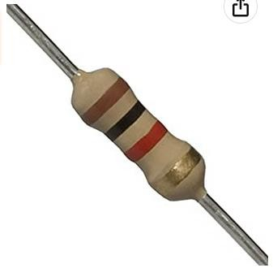

# Jumping Wires:

A wire is a flexible strand of metal. Wire is commonly formed by drawing the metal through a hole in a die or draw plate. Wire gauges come in various standard sizes, as expressed in terms of a gauge number.Wires are used to bear mechanical loads, often in the form of wire rope. In electricity and telecommunications signals, a "wire" can refer to an electrical cable, which can contain a "solid core" of a single wire or separate strands in stranded or braided forms.

Usually cylindrical in geometry, wire can also be made in square, hexagonal, flattened rectangular, or other cross-sections, either for decorative purposes, or for technical purposes such as high-efficiency voice coils in loudspeakers. Edge-wound coil springs, such as the Slinky toy, are made of special flattened wire.

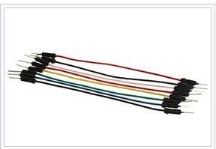

# Applications of the project:

* Maintaining social distancing using Ultrasonic Distance Sensor.
* Alert Occupants.
* Notify Authorities.
* Inspect All Equipment Regularly.

# Material Diagram:

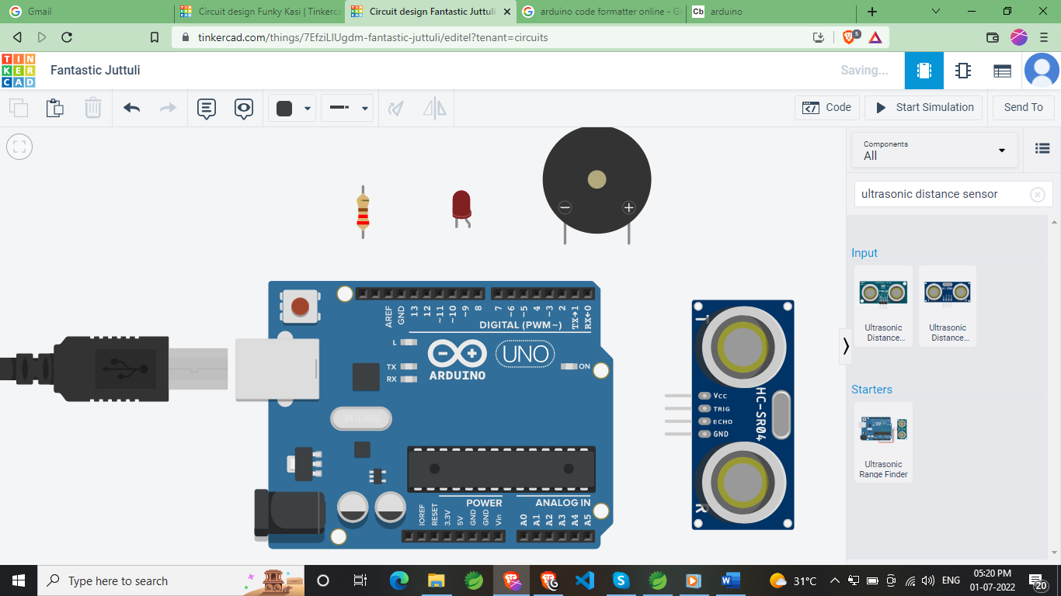

* Arduino Uno R3
* Ultrasonic Distance Sensor
* Piezo Buzzer
* Resistor (220 Ω)
* Different Colors of Wires

# Circuit Diagram:

**Step 1:** Connect GND supply (negative charge) to the Resistor Terminal 1.

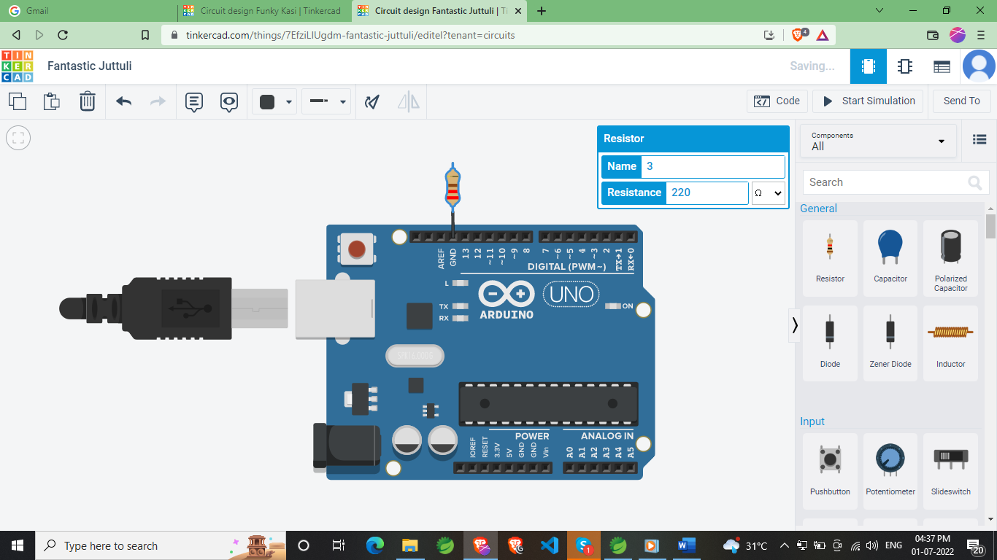

**Step 2:** Connect Red light Cathode to the Resistor Terminal 2 and Anode to D12.

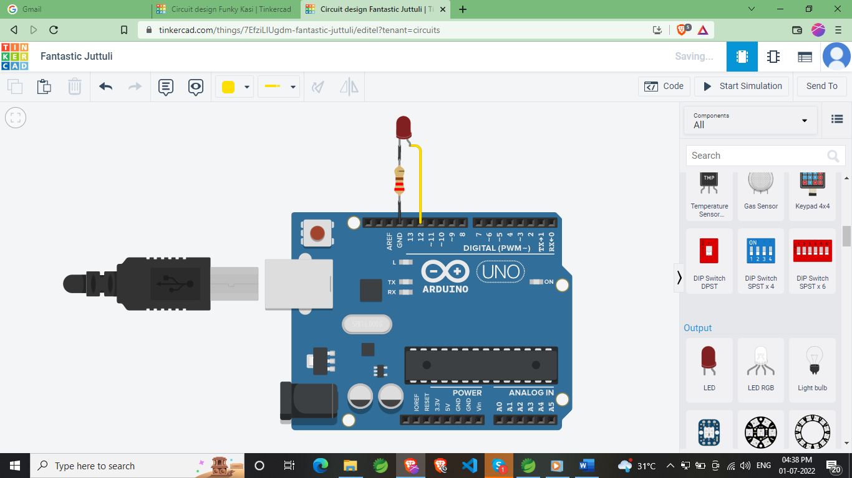

**Step 3:** Connect Ground with the Piezo Positive And D10 with Piezo Negative.

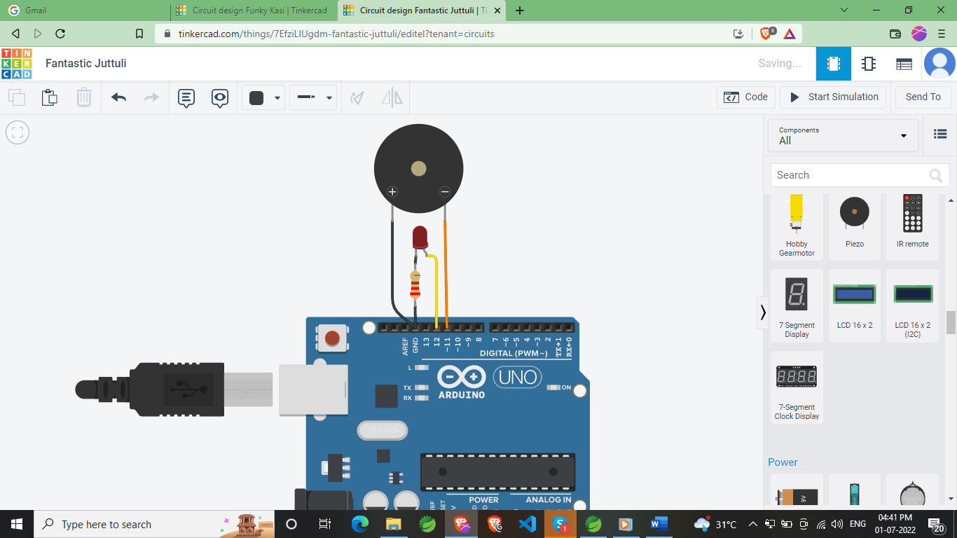

* **Step 4:** Connect positive charge with Ultrasonic Distance Sensor VCC pin, negative charge withnegative, D9 with Trigger Pin AndD10 with Echo pin.

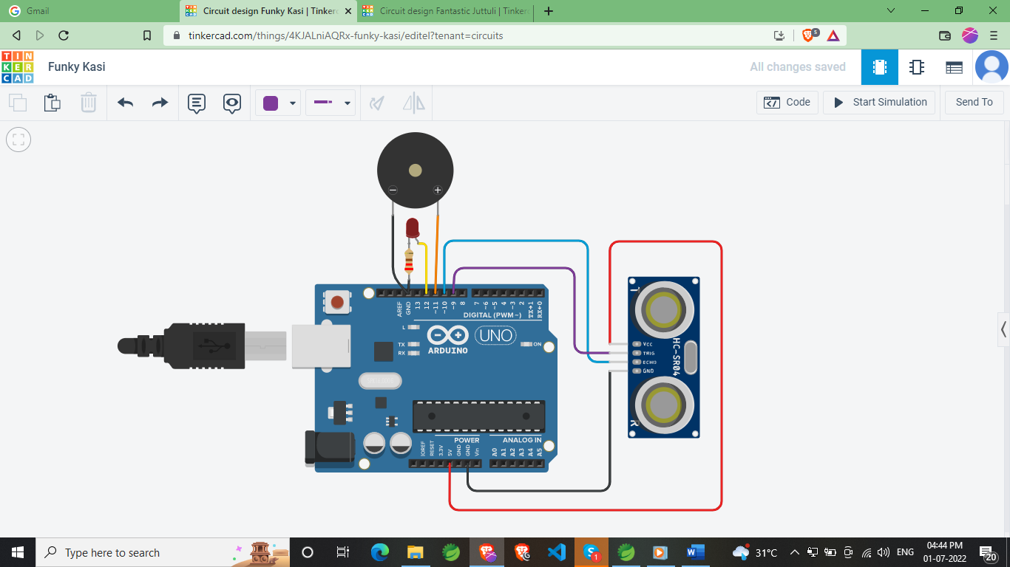

# Line of Code:

# const int ecoPin =10;

# const int trigerPin =9;

# long duration;

# int distanceCm, distanceInch;

# void setup() {

# Serial.begin(9600);

# pinMode(trigerPin, OUTPUT);

# pinMode(ecoPin, INPUT);

# pinMode(11, OUTPUT);

# pinMode(12, OUTPUT);

# }

# void loop(){

# digitalWrite(trigerPin, LOW);

# delayMicroseconds(2);

# digitalWrite(trigerPin, HIGH);

# delayMicroseconds(10);

# digitalWrite(trigerPin, LOW);

# duration = pulseIn(ecoPin, HIGH);

# distanceCm = (duration * 0.032)/2;

# distanceInch = (duration * 0.0133)/2;

# Serial.print("Distance : ");

# Serial.println(distanceCm );

# if(distanceCm < 100) {

# digitalWrite(11, HIGH);

# digitalWrite(12, HIGH);

# }else {

# digitalWrite(11, LOW);

# digitalWrite(12, LOW);

# }

# }

# Output By Clicking on Start Simulation:

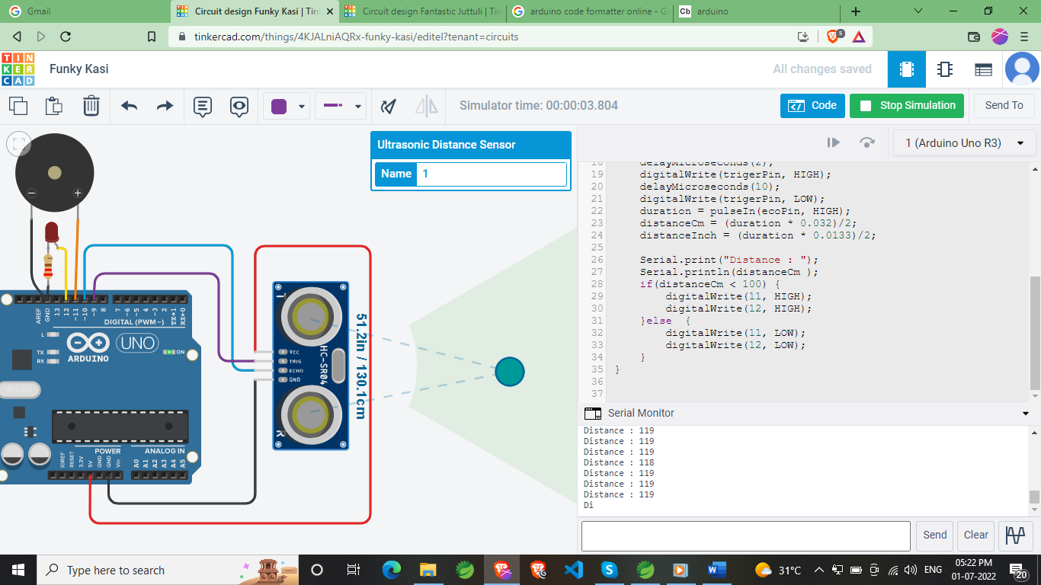

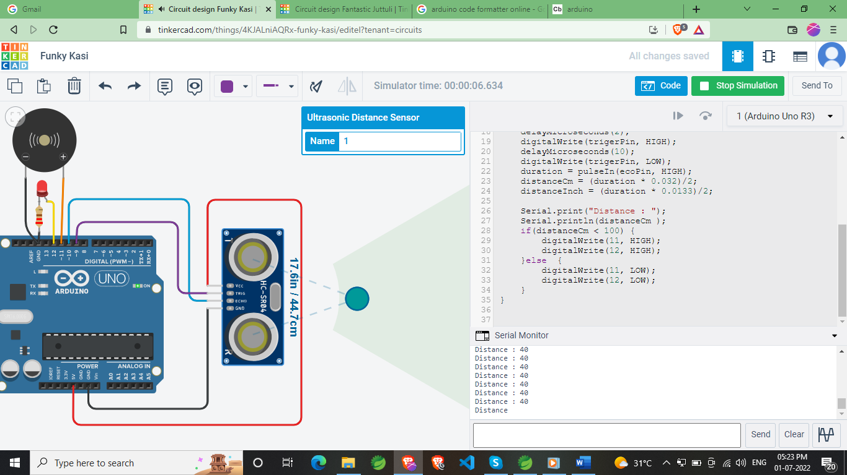

**Working of the Project:**

**How does it Work?**

Ultrasonic sensors work by emitting sound waves at a frequency too high for humans to hear. They then wait for the sound to be reflected back, calculating distance based on the time required. This is similar to how radar measures the time it takes a radio wave to return after hitting an object.

While some sensors use a separate sound emitter and receiver, it’s also possible to combine these into one package device, having an ultrasonic element alternate between emitting and receiving signals. This type of sensor can be manufactured in a smaller package than with separate elements, which is convenient for applications where size is at a premium.

While radar and ultrasonic sensors can be used for some of the same purposes, sound-based sensors are readily available—they can be had for just a couple dollars in some cases—and in certain situations, they may detect objects more effectively than radar.

For instance, while radar, or even light-based sensors, have a difficult time correctly processing clear plastic, ultrasonic sensors have no problem with this. In fact, they’re unaffected by the color of the material they are sensing.

On the other hand, if an object is made out of a material that absorbs sound or is shaped in such a way that it reflects the sound waves away from the receiver, readings will be unreliable.

If you need to measure the specific distance from your sensor, this can be calculated based on this formula:

Distance = ½ T x C

(T = Time and C = the speed of sound)

At 20°C (68°F), the speed of sound is 343 meters/second (1125 feet/second), but this varies depending on temperature and humidity.

Specially adapted ultrasonic sensors can also be used underwater. The speed of sound, however, is 4.3 times as fast in water as in air, so this calculation must be adjusted significantly.

If any one come to near the Ultrasonic sensors detect and Piezo start and red light start blinking.

# Advantages:

* Avoid to people come closer.
* Early Detection. If any person come near you the it will alert you.
* 24/7 Monitoring.
* Easy & Affordable.

# Summary:

A Social Distancing Maintaining system warns people when any parson near you are detected. These alarms may be activated automatically from person detectors near you activated via manual alarm activation devices such as manual call points or pull stations.

# Conclusion:

An end-to-end IoT enabled architecture has been proposed to manage social distancing during COVID-19 like pandemics. A detailed review of sensing and communication technologies which can be used for the purpose has been presented. It has been found that IoT technologies promised to support the requirement of social distancing at various indoors and outdoors environments due to the recent advancements in the design of sensing and communications infrastructure. Moreover, the challenges associated with each layer of IoT structure have been described and design guidelines to combat these challenges have also been presented. It is expected that the proposed architecture for ensuring end-to-end social distancing while providing the basic supplies shall help the individual citizens, governments and medical staff to deal with pandemics more efficiently.